

**Online shop system**

**Software Requirement Specification**

**Team 1**

– Hanoi, October 2023 –

Record of changeS

|  |  |  |  |
| --- | --- | --- | --- |
| Date | A* M, D | In charge | Change Description |
|  |  |  |  |
|  |  |  |  |
|  |  |  |  |
|  |  |  |  |
|  |  |  |  |
|  |  |  |  |
|  |  |  |  |
|  |  |  |  |
|  |  |  |  |
|  |  |  |  |
|  |  |  |  |
|  |  |  |  |

*A - Added M - Modified D - Deleted

**Table of Contents**

I. Overview 4

1. Introduction 4

2. System Functions 5

3. Entity Relationship Diagram 6

II. Functional Requirements 7

1. Login Screen 7

2. Register 7

3. Home Page 8

4. Product Details 9

5. Map 10

6. My Cart 11

7. Payment 12

8. My Orders 12

9. Order Details 13

10. ChatBox 14

11. Chat Detail 14

12. Account Detail 14

# I. Overview

## 1. Introduction

The shopping online system is an e-commerce platform that allows users to purchase products (phone or laptop). The system will be used in android environment and is accessible through mobile device with an internet connection. The users of the system are customers who are looking to purchase products.

Constraints for the system include the requirement for accurate product information and inventory management. Assumptions for the system include a stable internet connection and a functional web browser. Dependencies for the system include a database to store customer information and purchase history.

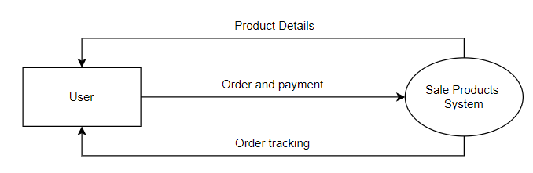

## 2. System Functions

#### a. Screen Flow

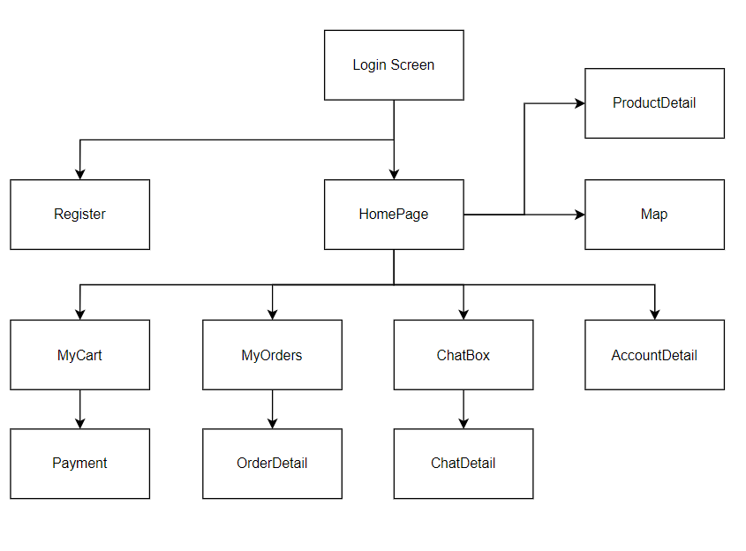

#### b. Screen Details

|  |  |  |
| --- | --- | --- |
| **#** | **Screen** | **Description** |
| 1 | Login Screen | This screen allows the user to login with exist account |
| 2 | Register | This screen allows the user to create new account |
| 3 | Home Page | - Show navigation bar: Home Page, Cart, My Order, Chat Box, Account Detail - Shown product list (phone and laptop) - Shown product information includes its discount, title, price; the user is redirected to the product's details on his/her clicking |
| 4 | Product Detail | - Show navigation bar: Home Page, Cart, My Order, Chat Box, Account Detail  - Show product details (including Title, images, discount, price and description)  - Button “Thêm vào giỏ hàng” to add product to cart |
| 5 | Map | - Show navigation bar: Home Page, Cart, My Order, Chat Box, Account Detail  - Show address of shop in map |
| 6 | My Cart | - Show navigation bar: Home Page, Cart, My Order, Chat Box, Account Detail  - Show the cart details with list of the user's chosen products (including title, price, quantity) and the total order price  -The user can:  + Change the quantity of each product: the total cost is automatically adjusted  + Choose to delete/remove product by clicking on the deleting icon  + Click the “Tiến hành thanh toán” button to go to the Payment Page Please notes: the user's chosen products from the last browsing session are remained in his/her cart until s/he submit the cart. However, the product prices are updated with the latest prices in the system |
| 7 | Payment |  |
| 8 | MyOrders | - Show navigation bar: Home Page, Cart, My Order, Chat Box, Account Detail  - Show the list of user's orders paginated - Each order includes below information: id, order status, order information (receiver’s name, phone number, address), total cost; - On clicking specific order, user would be redirected to the OrderDetail Screen |
| 9 | OrderDetail | - Show navigation bar: Home Page, Cart, My Order, Chat Box, Account Detail  - Order information: id, order status, order information (receiver’s name, phone number, address), total cost; - Show List of products in order: image, title, price, quantity  - Button “Hủy đơn hàng” to cancel order |
| 10 | ChatBox |  |
| 11 | ChatDetail |  |
| 12 | AccountDetail | - This screen allows the user to edit his/her profile information (including address, password)  - Button “Đăng xuất” to log out system |

#### c. Non-Screen Functions

|  |  |  |  |
| --- | --- | --- | --- |
| **#** | **Feature** | **System Function** | **Description** |
| 1 | Common | Log out | Log out system |
| 2 | … |  |  |

## 3. Entity Relationship Diagram

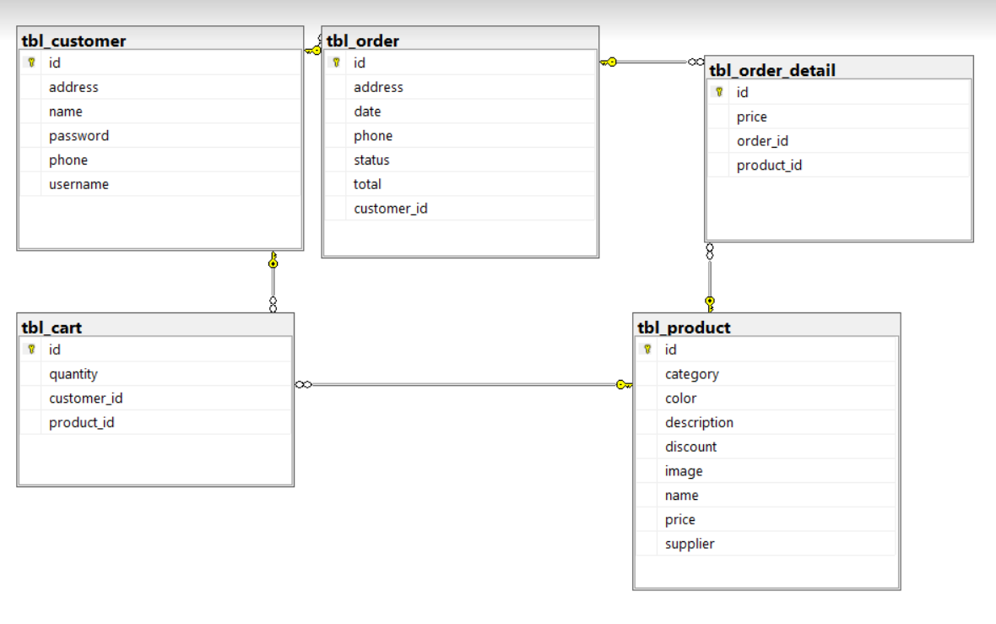

# II. Functional Requirements

## 1. Login Screen

* Function trigger: Open application
* Function description:
  + User input email and password to login into system
  + User can create new account by clicking “Don’t have account yet? Register”
* Screen layout:

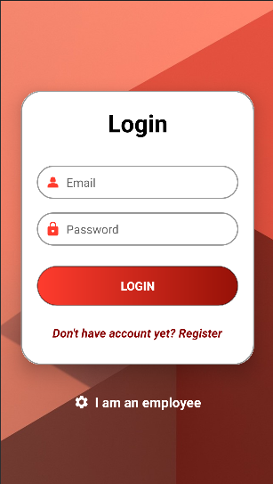

* Function Details:
  + User input username and password to login system
  + In case username or password is invalid, system will display inline error message “username/password is invalid”
  + In case username and password is valid, user log in to system successfully

## 2. Register

* Function trigger: Clicking “Don’t have account yet? Register” in Login Screen
* Function description: User create new account
* Screen layout:

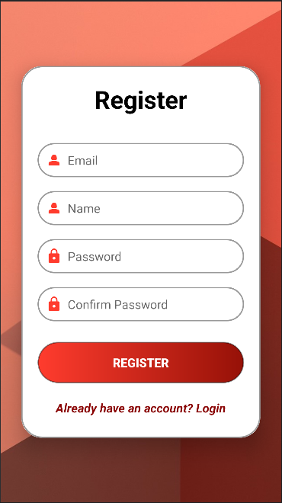

* Function Details:
  + User input all information to create new account
  + In case email is existed, system display error message “email has already existed”
  + In case email is valid
    - In case Password is not valid, system display error message “Password is not valid”
    - In case Confirm password is not like Password, system display error message “Confirm password is not valid”
    - In case password and confirm password is valid, system display message “Register successfully”

## 3. Home Page

* Function trigger: User login into system
* Function description:
  + Screen display list of products
* Screen layout:

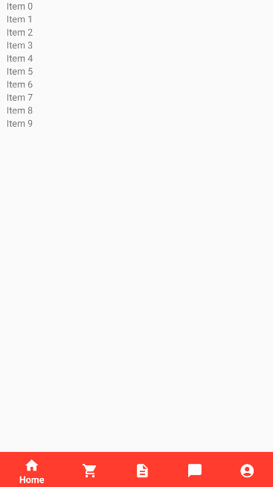 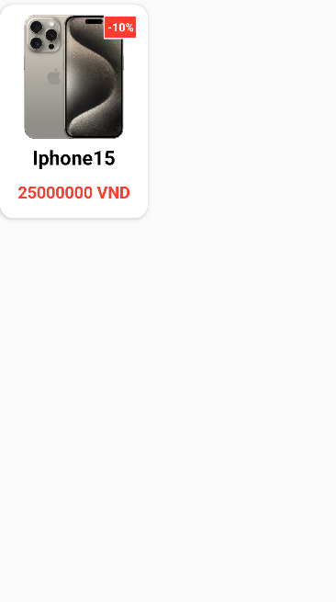

* Function Details:
  + Screen display Navigation bar:
    - Home Page
    - My Cart
    - My Orders
    - ChatBox
    - Account Detail
  + Screen display list of products, each Product contains information: image, discount, title, price
  + After clicking on specific product, user will be navigated to Product Detail

## 4. Product Details

* Function trigger: Clicking on product in Home Page or My Cart
* Function description: Screen display product details information
* Screen layout:

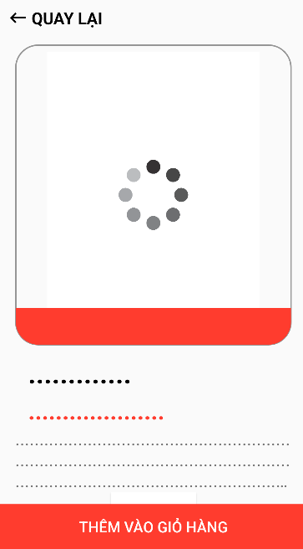

* Function Details:
  + Screen show product details information: images, title, price, description
  + Click on button “Quay lại” to navigate to previous screen
  + Click on button “Thêm vào giỏ hàng” to add product to cart

## 5. Map

* Function trigger: Click on Map icon in Home Page
* Function description: Display address of store in map
* Screen layout:

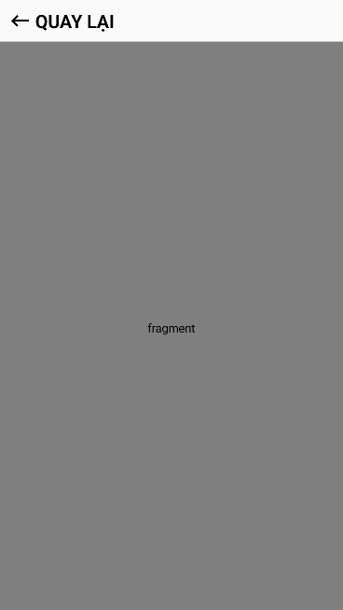

* Function Details:
  + Display address of store in map
  + Click on button “Quay lại” to return Home Page

## 6. My Cart

* Function trigger: Click on Cart icon on navigation bar
* Function description: display products in cart of user
* Screen layout:

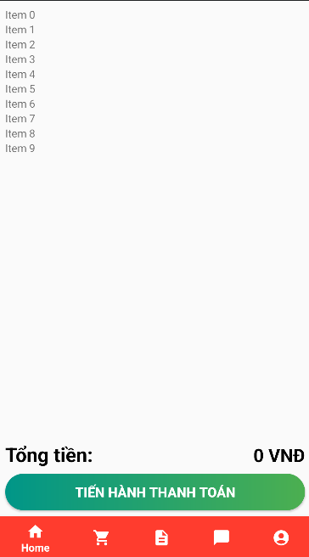 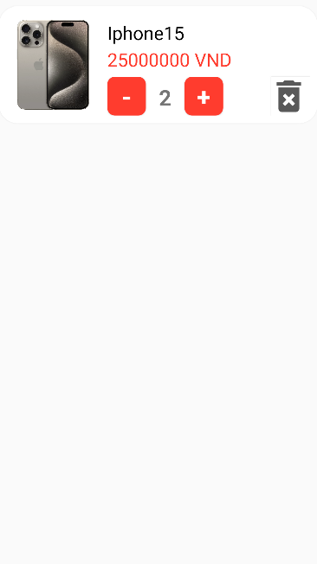

* Function Details:
  + Show the cart details with list of the user's chosen products (including title, price, quantity) and the total order price
  + The user can:
    - Change the quantity of each product: the total cost is automatically adjusted
    - Choose to delete/remove product by clicking on the deleting icon
    - Click on button “Tiến hành thanh toán” to go to the Payment Page

## 7. Payment

* Function trigger:
* Function description:
* Screen layout:
* Function Details:

## 8. My Orders

* Function trigger: Click on Orders icon in navigation bar
* Function description: display all orders of user
* Screen layout:

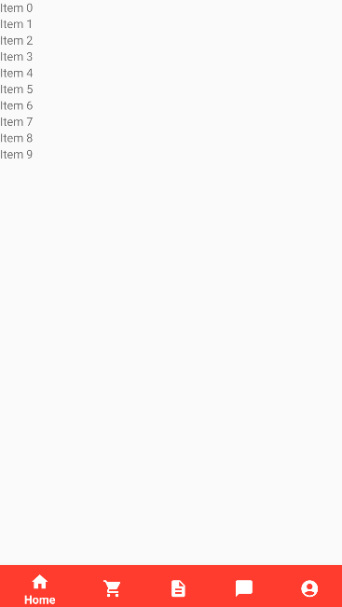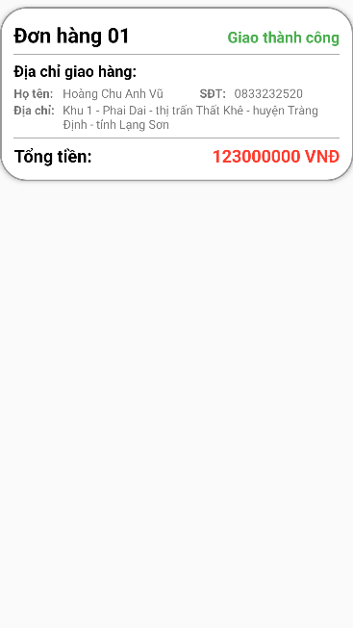

* Function Details:
  + Show the list of user's orders paginated
  + Each order includes below information: id, order status, order information (receiver’s name, phone number, address), total cost;
  + On clicking specific order, user would be redirected to the OrderDetail Screen

## 9. Order Details

* Function trigger: Click on specific order in My Orders screen
* Function description: Screen display order details information
* Screen layout:

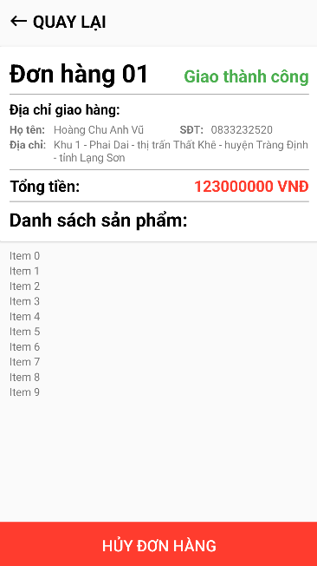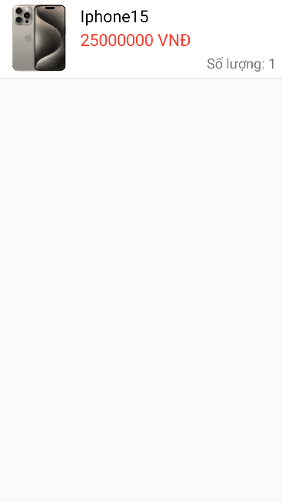

* Function Details:
  + Screen display Order information: id, order status, order information (receiver’s name, phone number, address), total cost;
  + Show List of products in order: image, title, price, quantity
  + Click on button “Hủy đơn hàng” to cancel order

## 10. ChatBox

* Function trigger:
* Function description:
* Screen layout:
* Function Details:

## 11. Chat Detail

* Function trigger:
* Function description:
* Screen layout:
* Function Details:

## 12. Account Detail

* Function trigger: Click on Account icon in navigation bar
* Function description: Screen display account information
* Screen layout:

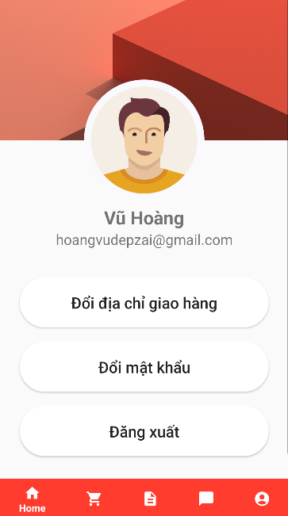

* Function Details:
  + Screen display account information: Name, email
  + Click on button “Đổi địa chỉ giao hàng” to display popup to update address
  + Click on button “Đổi mật khẩu” to display popup to change password
  + Click on button “Đăng xuất” to log out the system